


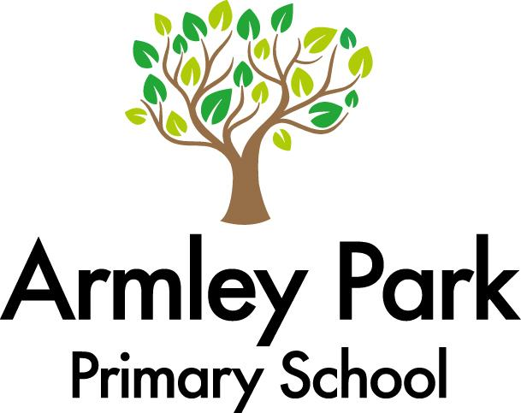
A huge welcome to Year 4! We hope you have had a lovely Christmas break. Please remember that swimming will continue on a Thursday from 16.01.25. Children will need an appropriate swimming costume and a towel in a sports bag.
Other areas of the curriculum
Geography – North America and the USA
Science – Electricity
P.E – Swimming
PSHE – Physical health and Wellbeing
Music – Stop! and Lean on me
DT – Textiles, Cross Stitch Bookmarks
Computing – Programming A – Repetition in Shapes
Data and information – Data Logging
R.E- How do the five pillars of Islam guide Muslims

Books we will be reading:

English
Our first piece of writing this half-term will be a Haiku poem about new year. We will then be writing character and setting descriptions based on different locations and characters in our class text; Swimming against the Storm. We will also be looking at a variety of other text types.

Maths
Below is a list of topics we are covering this term in Maths –
Week 1
Multiplication and Division
Week 2-4
Length and Perimeter
Week 5-8
Fractions
Weeks 9 -11
Decimals

Home learning
You can help your children at home by:
Reading+ homework
TT Rockstar’s
Mathletics

If you would like to discuss anything about our first topic or any of the learning taking place in Year 6 please feel free to speak with Mr Firmedow or Miss Hargreaves after school. Otherwise please contact the school office to arrange a meeting with us.
You can also use our class email address: year4@armleypark.owlcotesmat.org

Year 4 Learning Overview / Spring

