English
Our Writing this term will include several different types of text that will be linked to our History topic (Why the Romans Invaded Britain) and our class text: The Chronicles of Narnia: The Lion, The Witch and The Wardrobe. Children will have lots of opportunity to develop and improve their writing ability and creativity through daily Writing lessons.
A huge welcome to Year 4! We hope you have had a lovely summer and are ready for a great year of learning!
Book we will be reading:
If you would like to discuss anything about our first topic or any of the learning taking place in Year 4, there will be an opportunity during the Meet the Teacher event. Otherwise please contact the school office to arrange a meeting with Mr. Firmedow. You can also use our class email address: year4@armleypark.owlcotesmat.org

Other areas of the curriculum
History – The Romans – Why did the Romans invade Britain?
Science - Sound
P.E – Swimming
PSHE – Family and Relationships
Music – Mama Mia
DT – Structure and Bridges
Computing – Computing systems and networks – The internet

Home learning
You can help your children at home by:
- Reading frequently
- Practicing times tables
- Accessing the home learning page on our website

Maths
Below is a list of topics we are covering this term in Maths – There is also a link to the White Rose Maths website if your child would like to do some extra practise.
Week 1 to 4
Number: Place Value
Week 4-7
Number: Addition, Subtraction, Multiplication and Division
Week 8-12
Number: Multiplication and Division A
https://whiterosemaths.com/resources?year=year-5-new

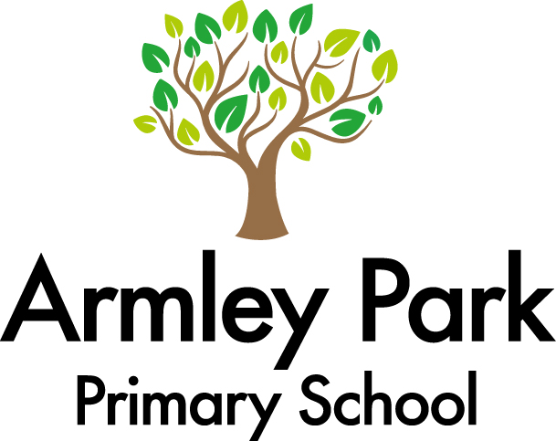
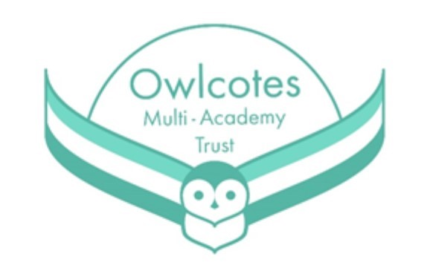
Year 4 Learning Overview / Autumn 1 2024
The Romans

