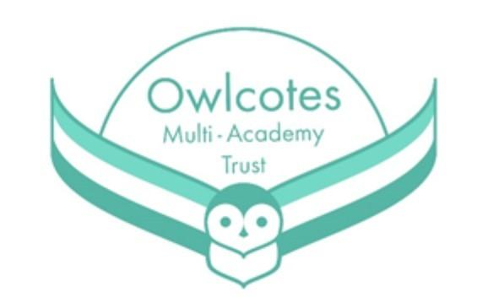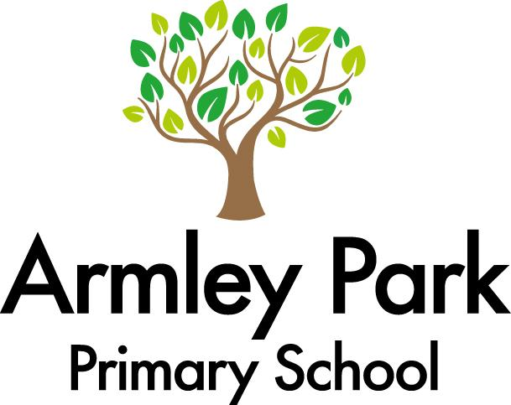

A huge welcome to Year 4! We hope you have had a lovely Christmas break. Please remember that swimming will continue on a Thursday from 18.01.24. Children will need an appropriate swimming costume and a towel in a sports bag.

**Other areas of the curriculum**

**Geography –** North America and the USA

**Science** – Electricity

**P.E** – Swimming and balancing

**PSHE** – Physical health and Wellbeing

**Music** – Stop! and Lean on me

**DT** – Textiles, Cross Stitch Bookmarks

**Computing** – Programming A – Repetition in Shapes

Data and information – Data Logging

**R.E-** How do the five pillars of Islam guide Muslims

Book we will be reading:



English

Our first piece of writing this half-term will be a Haiku poem about new year. We will then be writing character and setting descriptions based on different locations and characters in our class text; Swimming against the Storm. We will also be looking at a variety of other text types.

Maths

Below is a list of topics we are covering this term in Maths –

**Week 1**

Multiplication and Division

**Week 2-4**

Length and Perimeter

**Week 5-8**

Fractions

**Weeks 9 -11**

Decimals

**Home learning**

**You can help your children at home by:**

Reading+ homework

TT Rockstar’s

Mathletics

If you would like to discuss anything about our first topic or any of the learning taking place in Year 6 please feel free to speak with Mr Firmedow or Miss Morrison after school. Otherwise please contact the school office to arrange a meeting with us.

You can also use our class email address: year4@armleypark.owlcotesmat.org

Year 4 Learning Overview / Spring 1